**TESTING FINDINGS**

Following the same workflow for the not updating items issue, I have been recreating the same scenario to dig in each part involved in the creation/sync/update of items between Content Hub and CMP (Sitecore XP).

Steps to investigate the issue:

1. Modify Content hub item field and save changes.
2. Verify Message in raw audit log
3. Validate logs to see the current query sent to SOLR
4. Verify CMP searching by identifier ID and check modified field to see if it is up to date

**Content Hub Item Modified**

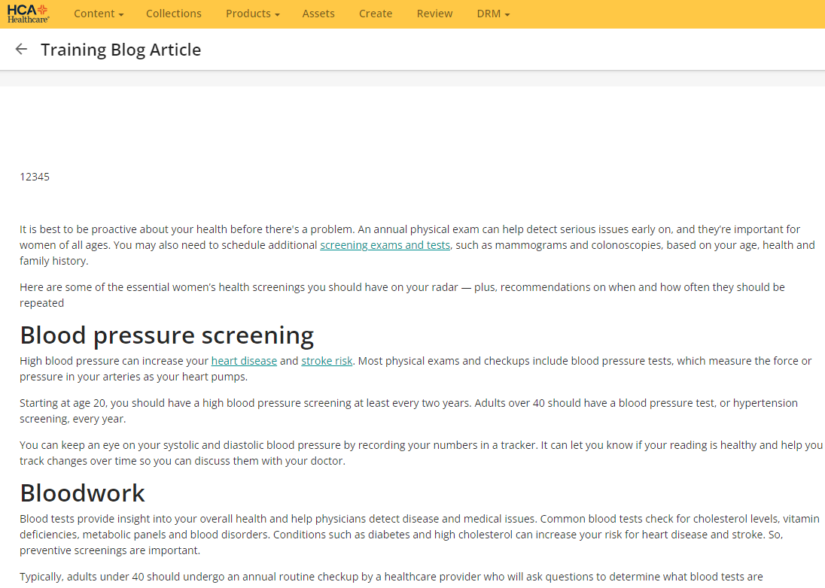

**AUDIT RAW LOG**



**SOLR QUERY LOGGED**

**[sitecore_master_index_shard1_replica_n4] webapp=/solr path=/select params={q=__solr_norm_field_name_s:(entityidentifier)+AND+_val_:__boost&fl=__solr_norm_field_name_s,_template,__solr_field_type_s,_uniqueid,_datasource&start=0&fq=_template:(455a3e98a6274b408035e683a0331ac7)&fq=_indexname:(sitecore_master_index)&rows=1&wt=xml} hits=1 status=0 QTime=5**

**CMP SYNCHRONIZATION**

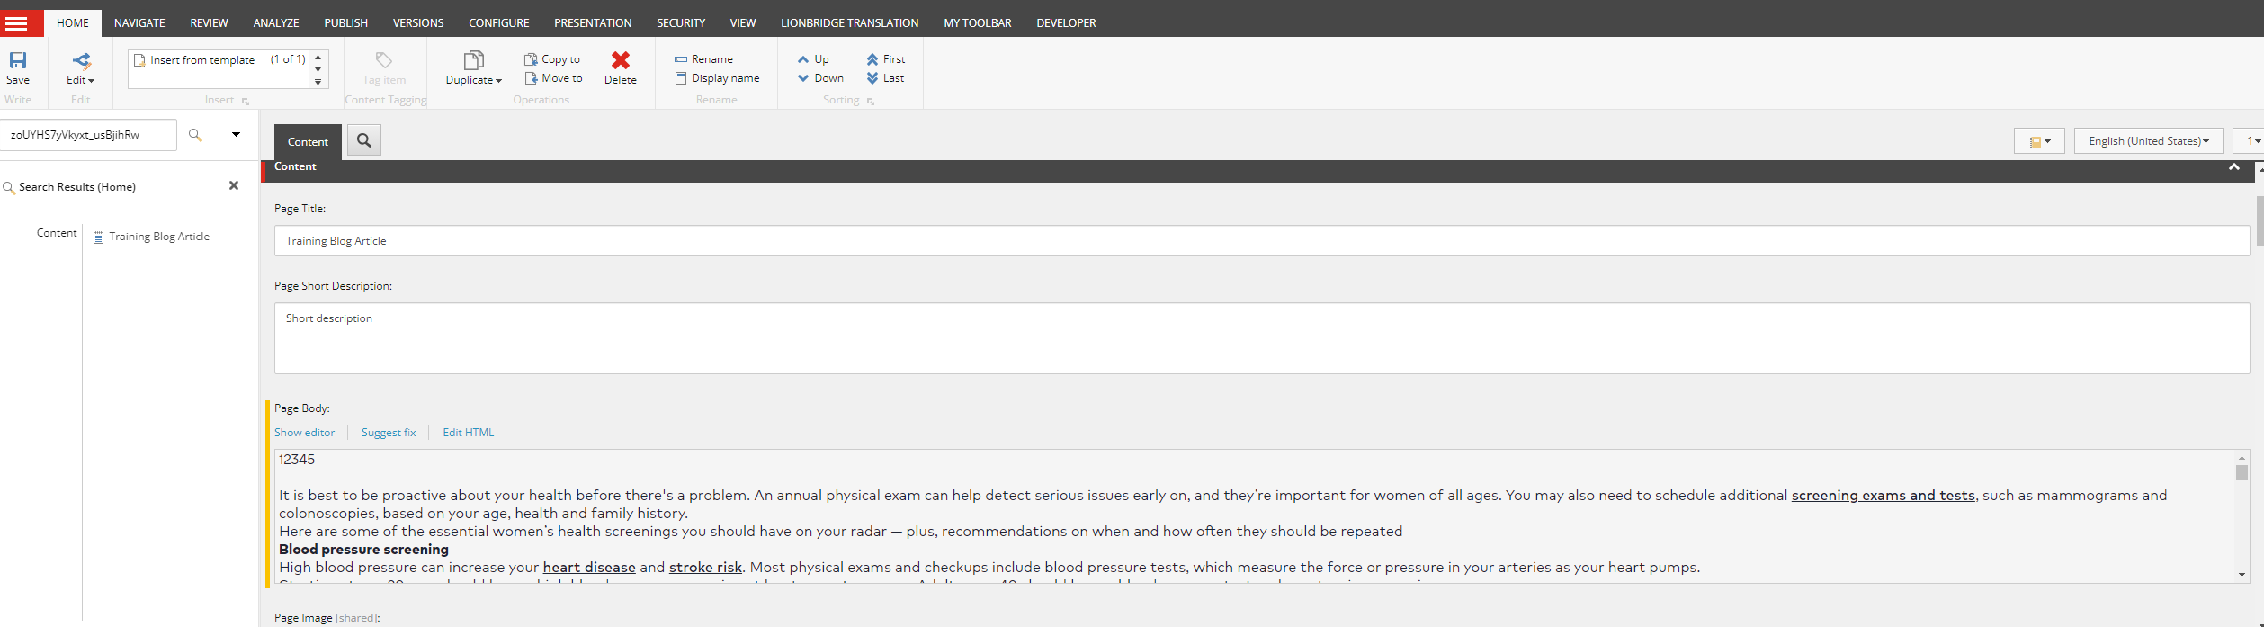

**Considerations:**

Due to the several tries and not able to reproduce the issue, the next step is to validate the current configuration of zookeeper, as this manages the SOLR replicas and maybe if the current item is not indexed that could lead in the creation / not updating the items correctly

Use a tool to validate the code inside the connector and check for some possible issues in the synchronization of items.

Check the current custom processor to validate if that implementation is inserting sometimes a bug and leads in sync issues